2021 MCA MCAN-293 L - OBJECT ORIENTED PROGRAMMING WITH JAVA LAB

## **Exam**

Name-Saheb Mukherjee

Roll.no:- 11571020039

**2.** We have to calculate the percentage of marks obtained in three subjects (each out of 100) by student A and in four subjects (each out of 100) by student B. Create an abstract class 'Marks' with an abstract method 'getPercentage'. It is inherited by two other classes 'A' and 'B' each having a method with the same name which returns the percentage of the students. The constructor of student A takes the marks in three subjects as its parameters and the marks in four subjects as its parameters for student B. Create an object for each of the two classes and print the percentage of marks for both the students.

* **//code**

1. import java.util.*;
2. abstract class Marks {
3. public abstract float getPercentage();
4. }
5. class A extends Marks {
6. int marks1, marks2, marks3;
7. A(int m1, int m2, int m3) {
8. this.marks1 = m1;
9. this.marks2 = m2;
10. this.marks3 = m3;
11. }
12. public float getPercentage() {
13. float total = ((marks1 + marks2 + marks3) / (float) 300) * 100;
14. return total;
15. }
16. }
17. class B extends Marks {
18. int marks1, marks2, marks3, marks4;
19. B(int m1, int m2, int m3, int m4) {
20. this.marks1 = m1;
21. this.marks2 = m2;
22. this.marks3 = m3;
23. this.marks4 = m4;
24. }
25. public float getPercentage() {
26. float total = ((marks1 + marks2 + marks3 + marks4) / (float) 400) * 100;
27. return total;
28. }
29. }
30. public class Student123 {
31. public static void main(String[] args) {
32. int s1, s2, s3, s4;
33. Scanner sc = new Scanner(System.in);
34. System.out.println("\n  Enter marks for Student A :");
35. System.out.println("---------------------------");
36. System.out.println("Enter marks for Subject1:");
37. s1 = sc.nextInt();
38. System.out.println("Enter marks for Subject2:");
39. s2 = sc.nextInt();
40. System.out.println("Enter marks for Subject3:");
41. s3 = sc.nextInt();
42. A a = new A(s1, s2, s3);
43. System.out.println("Percentage=" + a.getPercentage());
44. System.out.println("\nEnter marks for Student B :");
45. System.out.println("---------------------------");
46. System.out.println("Enter marks for Subject1:");
47. s1 = sc.nextInt();
48. System.out.println("Enter marks for Subject2:");
49. s2 = sc.nextInt();
50. System.out.println("Enter marks for Subject3:");
51. s3 = sc.nextInt();
52. System.out.println("Enter marks for Subject4:");
53. s4 = sc.nextInt();
54. B b = new B(s1, s2, s3, s4);
55. System.out.println("Percentage=" + b.getPercentage());
56. }
57. }

**OUTPUT**

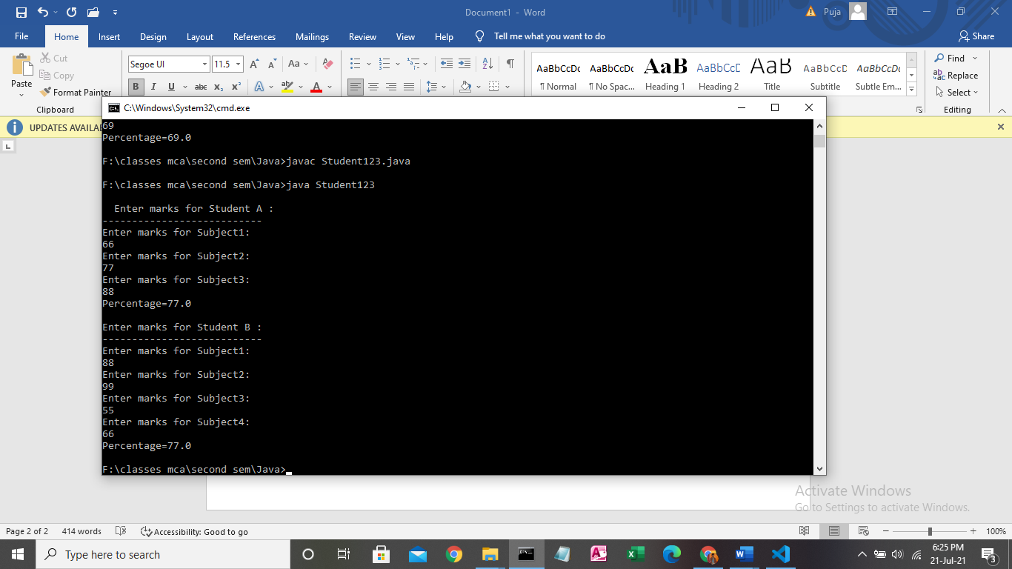

**3.**We have to calculate the area of a rectangle, a square and a circle. Create an abstract class 'Shape' with three abstract methods namely 'RectangleArea' taking two parameters, 'SquareArea' and 'CircleArea' taking one parameter each. The parameters of 'RectangleArea' are its length and breadth, that of 'SquareArea' is its side and that of 'CircleArea' is its radius. Now create another class 'Area' containing all the three methods 'RectangleArea', 'SquareArea' and 'CircleArea' for printing the area of 4 rectangles, 4 squares and 5 circles respectively. Create an object of class 'Area' and call all the three methods.

* **//CODE**

1. import java.util.Scanner;
2. abstract class Shape {
3. int length, breadth, side, radius;
4. abstract void rectangle_area(int length, int breadth);
5. abstract void square_area(int side);
6. abstract void circle_area(int radius);
7. }
8. class Area {
9. double pi = 3.14, rec, sq, ci;
10. void rectangle_area(int length, int breadth) {
11. System.out.println("\nRectangle Area=" + length * breadth);
12. }
13. void square_area(int side) {
14. System.out.println("\nSquare Area=" + side * side);
15. }
16. void circle_area(int radius) {
17. System.out.println("\nCicle Area=" + pi * radius * radius);
18. }
19. public static void main(String args[]) {
20. Scanner sc = new Scanner(System.in);
21. int i, l, b, s, j, r;
22. Area[] A = new Area[15];
23. for (i = 0; i < 14; i++) {
24. A[i] = new Area();
25. }
26. for (j = 0; j < 15; j++) {
27. A[j] = new Area();
28. }
29. i = 0;
30. System.out.println("\nRectangle Calculator");
31. System.out.println("--------------------");
32. for (i = 0; i < 4; i++) {
33. System.out.println("length");
34. l = sc.nextInt();
35. System.out.println("breadth");
36. b = sc.nextInt();
37. A[i].rectangle_area(l, b);
38. }
39. System.out.println("\nSquare Calculator");
40. System.out.println("-----------------");
41. for (i = 5; i < 9; i++) {
42. System.out.println("side");
43. s = sc.nextInt();
44. A[i].square_area(s);
45. }
46. System.out.println("\nCircle Calculator");
47. System.out.println("-----------------");
48. for (i = 10; i < 15; i++) {
49. System.out.println("radius=");
50. r = sc.nextInt();
51. A[i].circle_area(r);
52. }
53. }
54. }

**OUTPUT1**

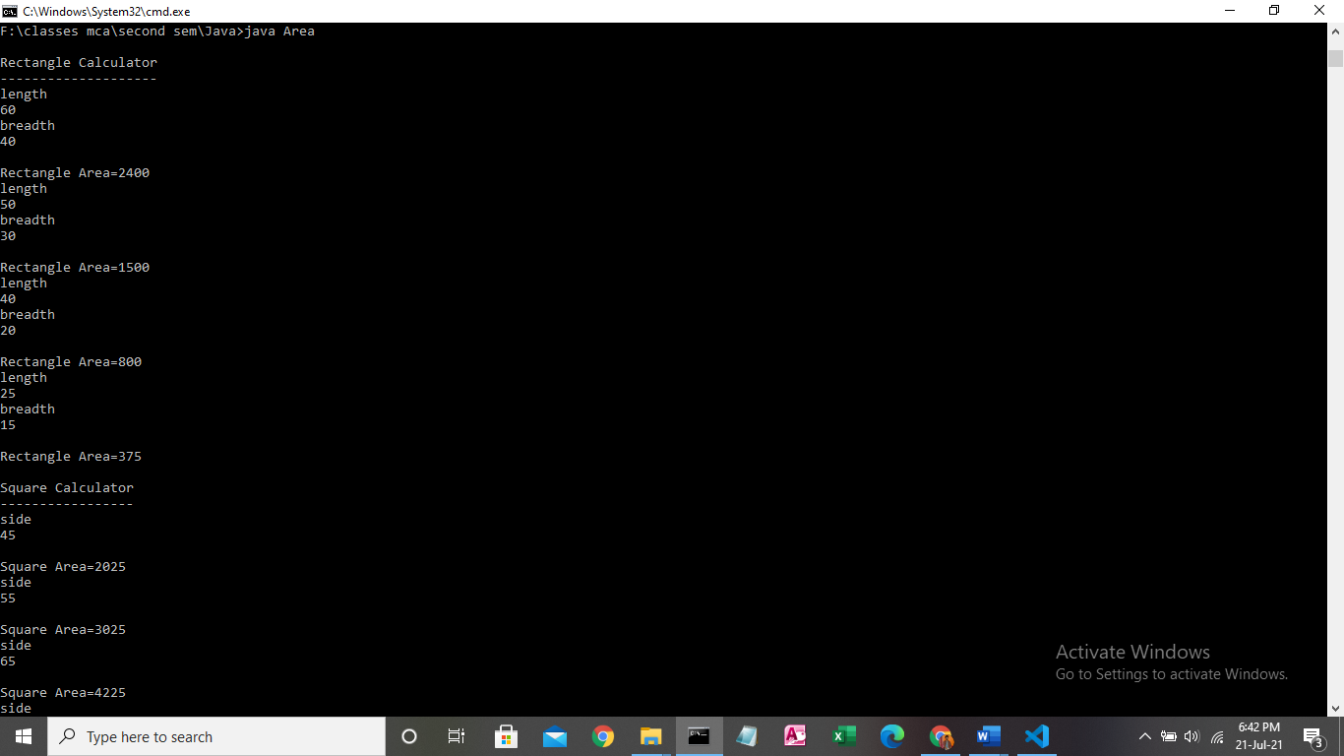

**OUTPUT2**

